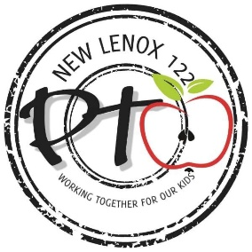
PTO Meeting Agenda
January 19, 2023

- Call to Order Sarah Meyer at 9:31a.m.
- Pledge of Allegiance
- Secretary Speaks: Sarah Meyer
- General greeting and welcome
- Introduction of Board
Executive Board:
- President: Nicole DeGrave
- Vice President: Tina Rauch
- Head Treasurer: Samantha Malicdem
- Assistant Treasurers: Julia McKibben and Megan Wendtland
- Secretary: Sarah Meyer
- Correspondence Secretary: Lauren Kaczmarski
- Sarah went over that there will be open positions on the board that will be available, President, Vice President, Secretary and Correspondence Secretary come April.

IV. Treasurer Report
- Presented by Julia McKibben (pto balance, what came in this month, what went out this month, school balances) $49,211.58

V. Dr. Motch presents: Get your tickets for Casino Night, January 21, 2023.

VI. Old Business

- The PTO received the most votes for the Scott’s Auto contest and received a donation of $750
- Rosati’s Dine and Donate January 10, 2023
- Bentley won the meeting attendance contest and received $1500 towards a fun purchase/event for the staff and students.

VII. Current Business
- CASINO NIGHT (promote) January 21st, $150 a couple, $100 per ticket
- BINGO event is February 11th from 11 to 1pm. BINGO is free! Concessions, 50/50 and raffle baskets. Volunteer sign up for adults and students will be going out next week.
- Heartwood Crafts DIY: orders must be made by February 17th.
- Auntie Anne’s and TCBY: orders must be made by February 14th.

VIII. New Business
- Read -a-Thon – end of February mystery readers start February 16th.
- VOLUNTEERS/Co-CHairs- needed for 2023 events - read-a-thon, 5K
- February 13th is a dine and donate at Oy’s
- Next meeting is Thursday, February 16th at 9:30a.m. at Liberty

X. Questions

XI. Spotlight
Spencer Pointe: Principal Dr. Kim Gray
Spencer Crossing: Principal Megan Calleros
Spencer Pointe/Crossing: Assistant Principal Jen Pender

XII. Call to Close (motion) Julia McKibben, followed by Sarah Meyer at 10:06 a.m.

Thank you for joining us today!
Respectfully submitted,
Sarah Meyer, Secretary NLSD 122 PTO

